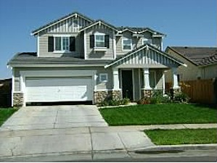
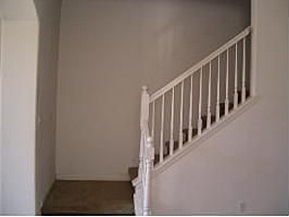
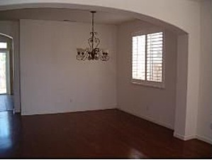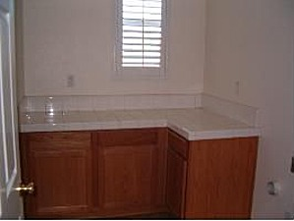
- 地址：3540 San Vincent Ave Merced CA 95348
房产编号：67091106
价格：$129,900 合 90万人民币
类型：别墅
卧室：3
卫生间：2
面积：1,457 sq ft 合 135平方米
花园面积：0 sq ft
估值：$128,500
2004年售价：$263,500
2009年财产税：$3,281
建筑年份：2004年
描述：3 Bedroom, 2 Bathroom Dunmore home, clean and cozy; fully landscaped; tile entry way, kitchen countertops; eat-in kitchen; formal dining area; good sized great room; indoor laundry; 2 car garage; and tile roof. A must see!

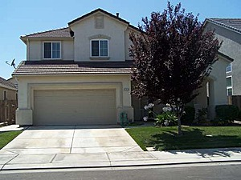
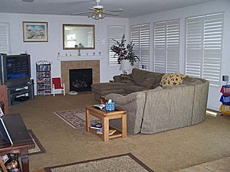
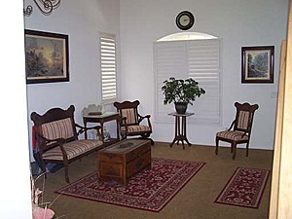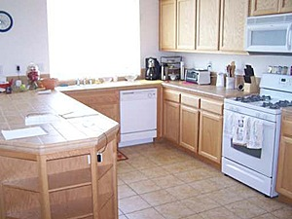

（2）地址：475 Zinnia Ct UNIT 00 Merced CA 95341
房产编号：2134368086
价格：$159,900 合111 万人民币
类型：别墅
卧室：4
卫生间：3
面积：2,113 sq ft 合 196平方米
描述：Fantastic Opportunity In Newer Merced Neighborhood. Beautiful Newer 4 Year Old, 4 Bed, 2.5 Bath Home In Excellent Condition With Lots Of Upgrades. Features Include Plantation Shutters, Tile Counter Tops And Floors, Ceiling Fans In Master Bedroom And Family Room. Back on the market as of 12/6/09.

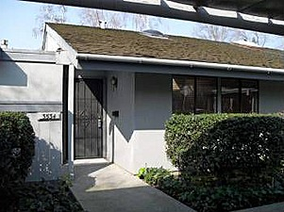
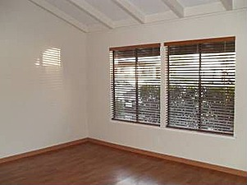
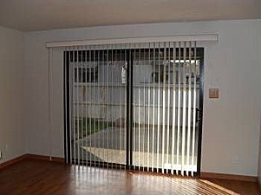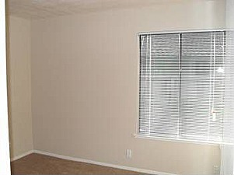
（3）地址：3534 W Benjamin Holt Dr Stockton CA 95219
房产编号：15302705
价格：$119,950 合83 万人民币
类型：公寓
卧室：3
卫生间：2
面积：1,217 sq ft 合113 平方米
花园面积：1,742 sq ft
估值：$125,500
2010年售价：$75,000
2009年财产税：$3,798
建筑年份：1973年
描述：Beautil Condo In Lincoln Village

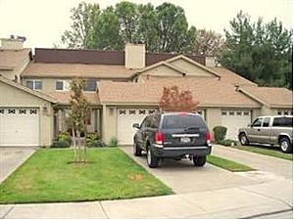
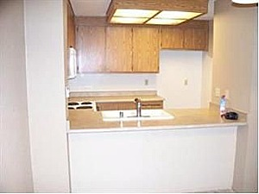
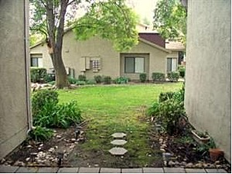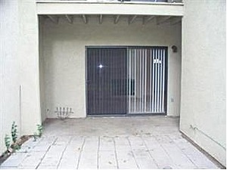
（4）地址：1624 Porter Way Stockton CA 95207
房产编号：63097948
价格：$70,000 合49 万人民币
类型：别墅
卧室：2
卫生间：2
面积：1,059sq ft 合98 平方米
估值：$96,000
2009年财产税：$1900
建筑年份：1985年
描述：Nice 2 Bedroom, 2 Bath Condo located in a quiet Cul-De-Sac at the end of Porter Way. Low maintenance property with slider from living room out to landscaped common area. Fireplace in living room and inside laundry area. Needs paint and maybe carpet.

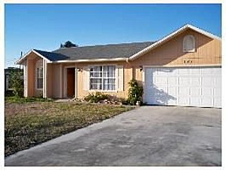
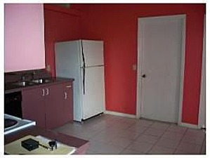
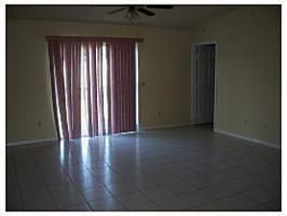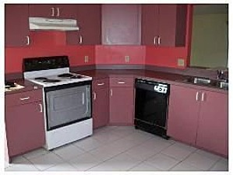
（5）地址：181 SW Twig Ave Port Saint Lucie FL 34983
房产编号：47821951
价格：$64,900 合45 万人民币
类型：别墅
卧室：3
卫生间：2
面积：1,800 sq ft 合167 平方米
花园面积：3,484,800 sq ft
估值：$95,000
2006年售价：$199,000
2009年财产税：$2603
建筑年份：1993年
描述：SOLID CBS HOME IN DESIRABLE NEIGHBORHOOD THAT IS CONVENIENT TO SCHOOLS, SHOPPING, 95 AND TURNPIKE...GREAT HOME FOR 1ST TIME BUYER OR INVESTOR.

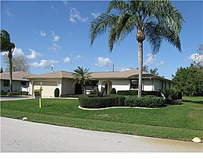
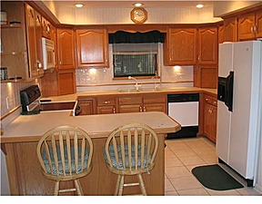
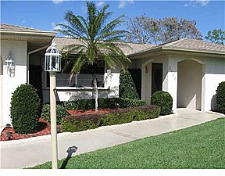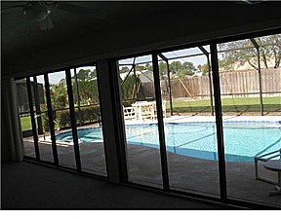
（6）地址：2466 SE Alden St Port Saint Lucie FL 34984
房产编号：47831978
价格：$136,999 合 96万人民币
类型：别墅
卧室：3
卫生间：2
面积：1,494 sq ft 合138 平方米
估值：$123,000
2009年财产税：$1819
建筑年份：1981年
描述：Beautiful well maintained home on a slow street. Wonderful landscaping and lawn. Pool is great with a solar heater. Almost new kitchen cabinets with indirect lighting. Nice lot with fencing on two sides. This home need no work----Just move in!!!!

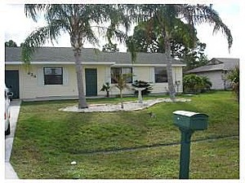
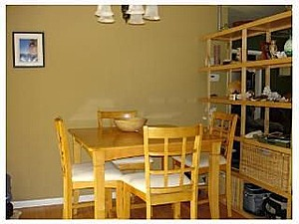
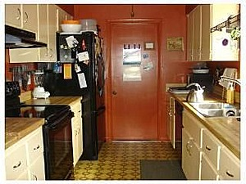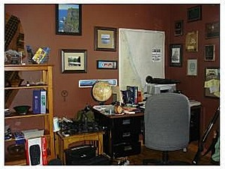
（7）地址：626 SW Lakehurst Dr Port Saint Lucie FL 34983
房产编号：47837029
价格：$55,900 合39 万人民币
类型：别墅
卧室：3
卫生间：2
面积：1,092 sq ft 合101 平方米
估值：$77,000
2003年售价：$77,000
2009年财产税：$1639
建筑年份：1982年
描述：Neat 3/2/1 with laminate floors in living area, parquet in bedrooms, vinyl in kitchen, vinyl siding, roof replaced in 2004, shed, fenced yard.

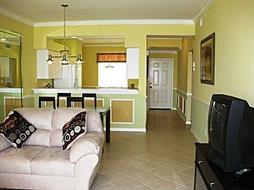
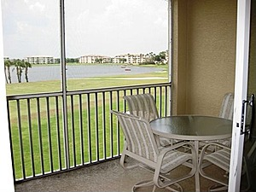
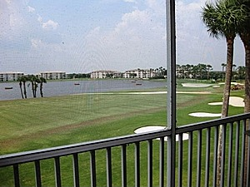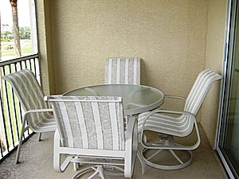
（8）地址：10450 Washingtonia Palm Way APT 1435 Fort Myers FL 33966
房产编号：58169386
价格：$134,500 合 94万人民币
类型：公寓
卧室：2
卫生间：2
面积：1194 sq ft 合110 平方米
估值：$131,000
2009年售价：$128,300
2009年财产税：$233
建筑年份：2001年
描述：Heritage Palms resort living in this 3rd floor Ashbury with 2 bedrooms, 2 baths and the beautiful 38 acre Aqua Range. This property is within walking distance to the clubhouse, tennis courts and main pool. It is tastefully furnished with new furniture in the living room, dining room and master bedroom. It is offered TURNKEY and is in immaculate condition. Upgraded with diagonal tile throughout, carpeted bedrooms and newly renovated with crown molding, chair rails and shadow boxes. This unit is ready for the discriminating buyer to bring their clothes and move in. Heritage Palms is a 36 hole Championship Bundled golf community with an award winning restaurant, multiple tennis courts, the Lodge which includes a billiards and card room, library, meeting room and the Tiki Bar.
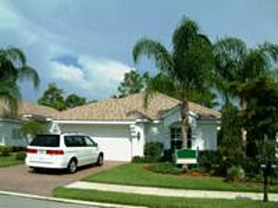
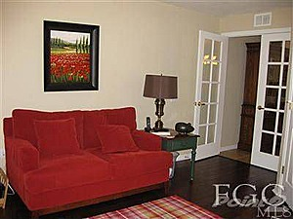
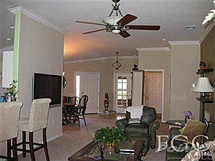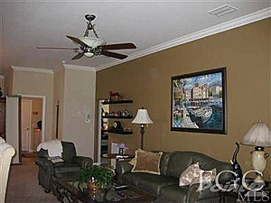
（9）地址：9968 Horse Creek Rd Fort Myers FL 33913
房产编号：68100351
价格：$224,900 合157 万人民币
类型：别墅
卧室：3
卫生间：2
面积：1730 sq ft 合180 平方米
花园面积：6,621 sq ft
估值：$198,500
2005年售价：$279,900
2009年财产税：$4923
建筑年份：2005年
描述：This is the highly desired BELMONT floor plan. It can be a true 3 bedroom or the 3rd room can be a den. This unit has new carpet throughout and hand scraped dark oak wood floors in the den/3rd bedroom. There is crown molding in the main living area and new paint throughout. The kitchen has white cabinets and Formica counters and oversized tile with white appliances. The master bathroom features dual sinks and a large shower. THIS IS A SOCIAL MEMBERSHIP HOME! Brokered And Advertised By: Sloan Realty, Inc.Listing Agent: Genice Sloan
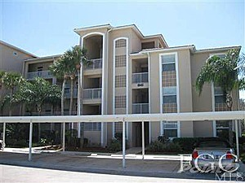
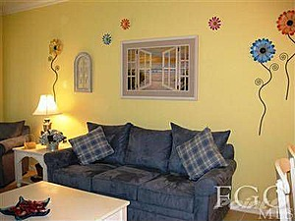
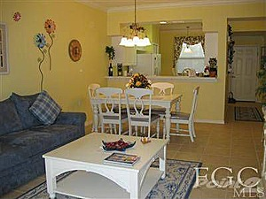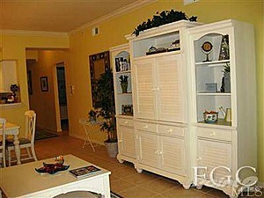
（10）地址：10461 Washingtonia Palm Way APT 3415 Fort Myers FL 33966
房产编号：63396214
价格：$128,800 合90 万人民币
类型：公寓
卧室：2
卫生间：2
面积：1070 sq ft 合 99平方米
花园面积：10,768 sq ft
估值：$129,000
2003年售价：$142,000
2009年财产税：$2377
建筑年份：2003年
描述：This is a first floor Ashbury that is offered TURNKEY. It is decorated in yellows and blues and is a very bright, airy unit. There is tile in the entry, kitchen, main living area and bathrooms. There is a king size bed in the master bedroom and twin beds in the guest room. The kitchen has a cafe style table in the breakfast room, white raised panel cabinets and Formica counters. Heritage Palms is a BUNDLED golf community with two 18 hole Championship courses, a 28,000 sq. ft clubhouse which has a restaurant, bar, golf pro shop, fitness center, large pool and spa and the tennis pro shop. The Lodge has a resort style pool, Tiki Bar, meeting & card rooms. Heritage Palms is 10 minutes from SW Florida International Airport, just minutes from restaurants, shopping and entertainment.
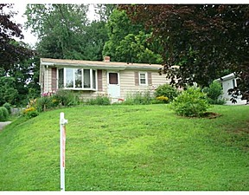
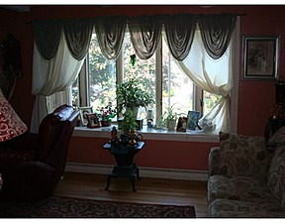
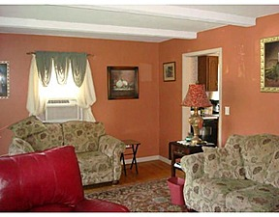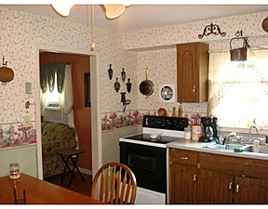
（11）地址：Address undisclosed Holyoke MA 01040
房产编号：2142549290
价格：$158,000 合 110万人民币
类型：别墅
卧室：4
卫生间：2
面积：1,774 sq ft 合164 平方米
花园面积：11,761 sq ft
建筑年份：1960年
描述：Opportunity knocks to move into a great neighborhood and do a little TLC. Needs new kitchen cabinets and some sweat equity. Hardwood floors under carpeting on main level, 3 finished rooms and a full bath in basement. Owner transferred.

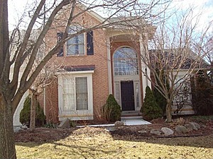
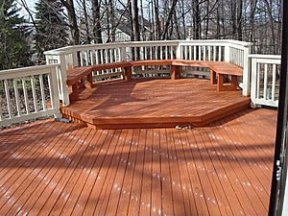
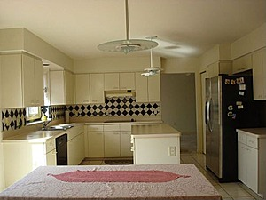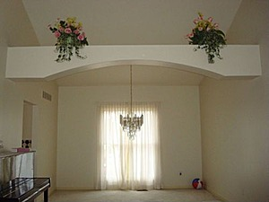
（12）地址：28476 Golf Pointe Blvd Farmington Hills MI 48331
房产编号：2132575933
价格：$320,000 合224 万人民币
类型：别墅
卧室：4
卫生间：3.5
面积：2,650 sq ft 合 246平方米
建筑年份：1995年
描述：This is a Contemprary Colonial At a Great Price! Dramatic 2-story Foyer. Cathedral Ceiling in Living and Formal Dining Room. Master Bedroom Has Cathedral Ceiling, Walk-in Closets, Jetted Tub & Double Sinks. Spacious contemparary Kitchen. Finished Basement Has Wet Bar, Formica Finished Cabinets and Full Bath.

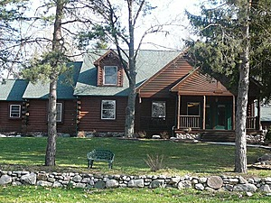
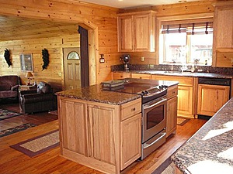
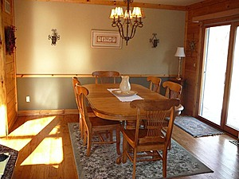
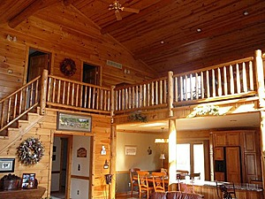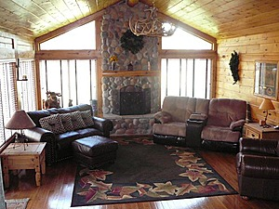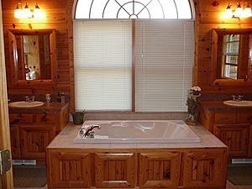
（13）地址：1851 E Predmore Rd Oakland MI 48363
房产编号：2139057912
价格：$875,000 合 612万人民币
类型：别墅
卧室：4
卫生间：4
面积：3276 sq ft 合 304平方米
建筑年份：2005年
描述：Magnificent One Of A Kind Log Home On 11 Wooded Acres! Up North Only 10 Minutes From Downtown Rochester! Log Interior And Exterior Custom Built! Stone F/p In Fam Rm And Gr Rm. 1st Fl Mstr, Granite Counters, Hdwd Fl In Fam Rm, Kit, Gr Rm. Soaring Ceilings!!
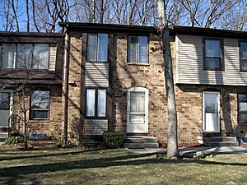
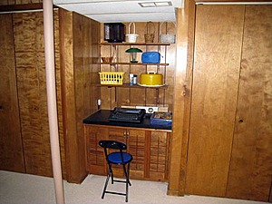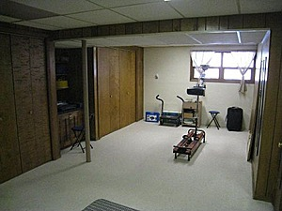
（14）地址：2541 Chatham Woods Dr SE # 27 Grand Rapids MI
房产编号：23880907
价格：$87,900 合 61万人民币
类型：公寓
卧室：2
卫生间：2
面积：1,328 sq ft 合123 平方米
估值：$93,500
2009年财产税：$1,360
建筑年份：1972年
描述：Location- Location - Location! This has it all. Close to shopping, the highway, the airport, everything within close proximity. Sharp two story condo in Chatham Woods. Beautiful wooded setting with deck backing up to a subdivision of 200,000 plus homes with woods as a buffer. This condo association has a club house and a pool area. Tastefully decorated - this condo has a large living room with sliders off it onto a large deck. Lots of wildlife can still be found on these wooded grounds. Top Quality throughout. All appliances are included (stove, refrigerator, washer, dryer, microwave and dishwasher) and all are in good shape. 2 Bedrooms upstairs are very spacious with lots of closet space. Kitchen is very convenient with pass through to dining area. Dining area has built-in shelves plus counter space.
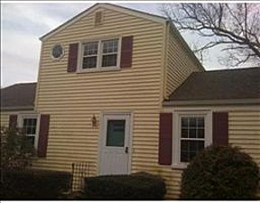
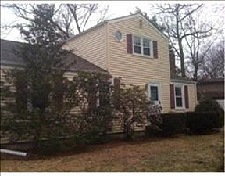
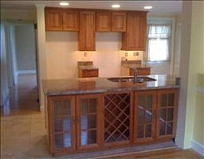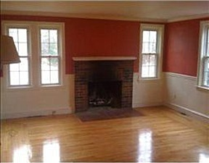
（15）地址：50 Gillan Ave Warwick RI 02886
房产编号：66083503
价格：$190,050 合133 万人民币
类型：别墅
卧室：4
卫生间：2
面积：1,390 sq ft 合129 平方米
花园面积：7000 sq ft
估值：$223,000
2009年财产税：$3521
建筑年份：1950年
描述：Lots Of Newer Features: Kitchen With Granite Counters, Furnace,Roof, Fence. Has Brick Fireplace, Refinished Hardwoods. 2 Year Homeowner Warranty For Owner Occupied, Sold "As Is, Where Is", No Disclosures

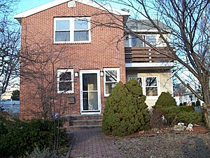
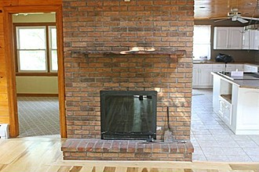
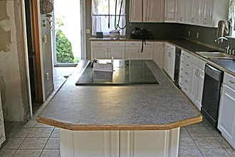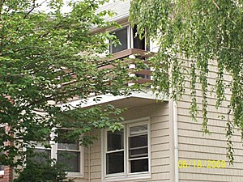
（16）地址：7 Princess Ave Cranston RI 02920
房产编号：66024752
价格：$249,500 合 174万人民币
类型：别墅
卧室：3
卫生间：2.5
面积：1560 sq ft 合 144平方米
花园面积：5,311sq ft
估值：$212,500
2009年财产税：$4032
建筑年份：1984年
描述：A must see home! newly painted beige interior through out, new Berber carpets in bedrooms. Balcony off master bedroom. Office or nursery room off master bedroom (not included in bedroom count) 2 sets of laundry hook ups. Spacious rooms! Near shopping, schools and parks. Great neighbors and good neighborhood. Note: 1560 inside sq.ft. does not include finished basement mother in-law.

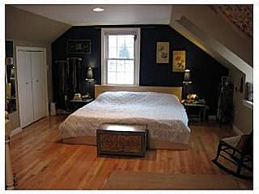
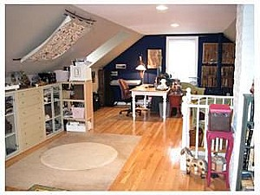
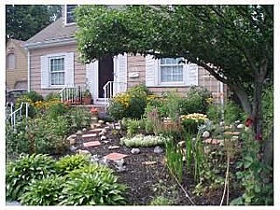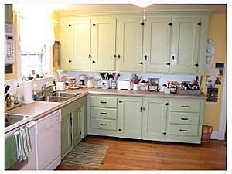
（17）地址：165 Whitford Ave Providence RI 02908
房产编号：66088200
价格：$175,000 合 122万人民币
类型：别墅
卧室：3
卫生间：1
面积：1,440 sq ft 合133 平方米
花园面积：4,356 sq ft
估值：$184,500
2009年财产税：$4,961
建筑年份：1937年
描述：GORGEOUS GARDENS IN ELMHURST. LOVELY CAPE WITH 3 BED POTENTIAL. CHARMING ANTIQUE CORNER HUTCH & KITCHEN CABINETS. SPECIAL DETAILS INCLUDE GLASS DOOR KNOBS & HARDWOOD FLOORS. BEAUTIFUL MASTER BEDROOM ON ENTIRE SECOND. PRIVATE YARD & DETACHED GARAGE.

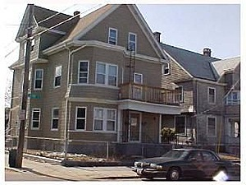
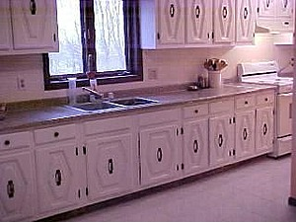
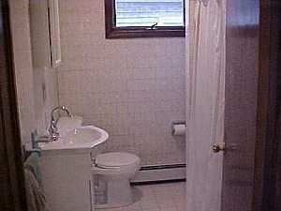
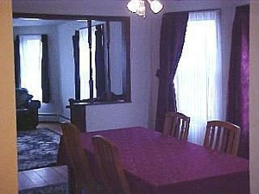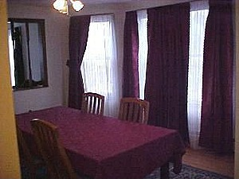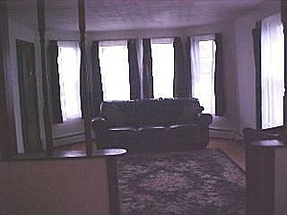
（18）地址：92 Clyde St Pawtucket RI 02860
房产编号：2132936541
价格：$79,900 合55 万人民币
类型：公寓
卧室：3
卫生间：1
面积：1,103 sq ft 合 102平方米
建筑年份：1920年
描述：WHY RENT WHEN YOU CAN BUY? LOW PRICE FOR LOTS OF SPACE - DOUBLE PARLOR, 3 BEDROOMS, BEAUTIFUL HARDWOODS, FRESHLY PAINTED, FRONT PORCH, NEW FURNACE, GARAGE, PETS OKAY, CENTRALLY LOCATED, MUST SEE!
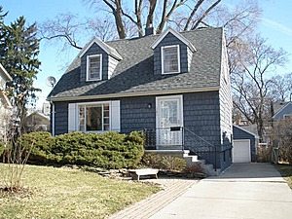
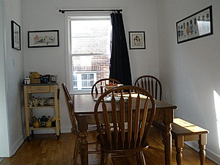
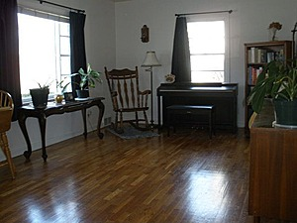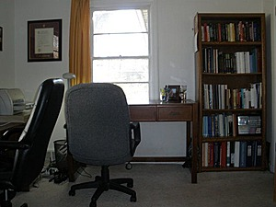
（19）地址：342 University Dr East Lansing MI 48823
房产编号：74037557
价格：$177,900 合 124万人民币
类型：别墅
卧室：3
卫生间：1.5
面积：1,400 sq ft 合130 平方米
估值：$178,500
描述：Charming home in the heart of Chesterfield Hills. Fabulous family room addition. Hardwood floors and a flexiable floor plan.

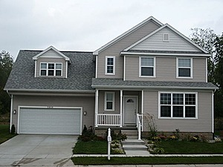
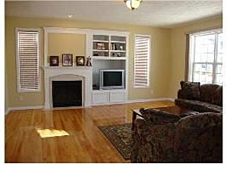
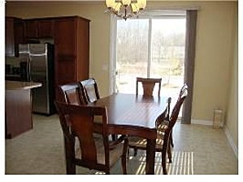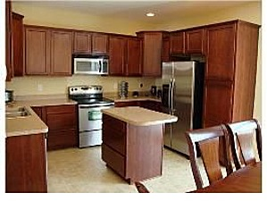
（20）地址：3810 Kiskadee Dr East Lansing MI 48823
房产编号：74695832
价格：$204,900 合 143万人民币
类型：别墅
卧室：3
卫生间：2.5
面积：2000sq ft 合 185平方米
花园面积：7420 sq ft
建筑年份：2005
描述：Unbelievable views front and back. Golf course from the front & the walking trail and trees from the back. Lots of upgrades!! Spectacular views from front and back-from the front views of the golf course and from the back the fantastic walking trail & trees! Lots of upgrades including additional square footage added to the great room, loft and master bedroom. Beautiful entertainment center and gas fireplace flanked by windows in the great room, gorgeous hardwood floors too. Upgraded cabinetry and stainles s appliances in the kitchen plus a center island. The dining room has a slider to the lovely backyard. Master bedroom suite has additional space and an additional window for lots of light. The larger than usual loft has a fabulous view of the golf course. This home has a finished lower level with space for a family room and an office with 2 egress windows. Storage room area plumbed for a bath & wet bar. Nine foot ceilings on the first floor and lower level.

